A Week in Review
Alex Shvartsman

STATE CHAMPIONSHIPS
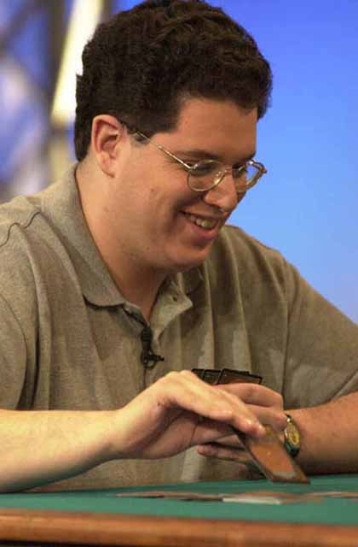
This tournament series took place over the weekend, and at the time this article is being written the results are still pouring in. Few high profile players seem to have won, except Billy Jensen and Mike Turian.
Jensen and Pikula (2nd in New York) were two of a huge number of people to succeed with a red-green aggressive deck based around Fires of Yavimaya. Other successful deck types included Nether-Go (Black-Blue control), U/W control and Rebels.
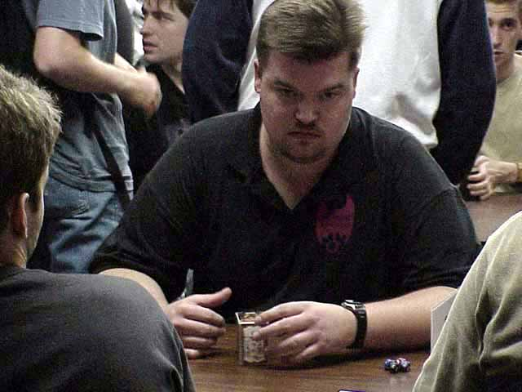
The most interesting deck played at States that we know of so far was that of Darwin Kastle. Kastle, credited with building the original Living Death deck, went back to his favorite strategy. His U/W deck used Fact or Fiction and Reviving Vapors to discard various Elder Dragons and then get them into play via Death or Glory. Kastle did not manage to make top 8, but the deck sure sounds fun.
The most current list of Championship winners can be found here. The Sideboard will continue to bring you deck lists and articles, further examining the results of this tournament.

NORDIC CHAMPIONSHIPS
Masters semifinalist, Trey Van Cleave
Mattias Jorstedt (Sweden) defeated Svend Geertsen (Denmark) in the finals of this tournament. Jorstedt was playing a white-green-red Blastogeddon deck designed by Trey Van Cleave. Geertsen was playing a U/W control deck and beat a number of R/G and W/G decks along the way (he also defeated Jorstedt 2-0 in the swiss rounds) but was unable to win the all-important final match.
Although Jorstedt does not have many top career finishes (his best performance being 19th at PTNY '00), he is well known among European players. Geertsen has 3 Pro Tour top 8's, including a fourth place finish at the 1997 World Championship.

COMING UP: Extended PTQ Season, GP Phoenix and GP Kyoto

GP Phoenix 11/10-11/12
GP Kyoto 11/11-11/12
The new Extended qualifier season is upon us. This weekend will kick it off with a number of Qualifier tournaments and two Grand Prix in different regions of the world. Americans will travel west to attend Grand Prix: Phoenix, while Asian players will visit the ancient capitol of Japan to attend GP: Kyoto.
This weekend will set the metagame for the season and display whether Invasion has had a significant impact on the format. So far, the Masters series tournament held recently at Pro Tour: New York is setting the trends in Extended. The most popular deck archetype appears to be "TradeSurvival" that actually won the tournament, followed by Trix.

WotC HIRES FROM MAGIC COMMUNITY
Two important members of the Magic community have recently been hired by Wizards of the Coast R&D department.
Brian Schneider (Virginia) is considered by many to be one of the very best deckbuilders in the world. Although Schneider has done his best to maintain a very low profile throughout his Magic career, his ideas and advice are coveted by most pro players. He will now put his skills to use designing new cards rather than trying to break them.
Rei Nakazawa (Florida) is best known for his articles in InQuest and various online publications. Nakazawa recently took over Mark Rosewater's duties at writing Magic: The Puzzling for TopDeck magazine. His new position at R&D is Continuity Manager and will have him involved in naming the cards and writing flavor text.
If you want to work for WOTC too, check out this opportunity.

YOUR MANA'S WORTH - THE FORGOTTEN DRAW STEP
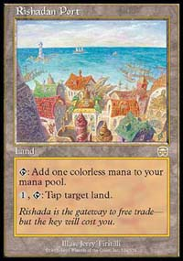
Most players assume that by drawing a card they have entered their main phase. This misunderstanding of the Magic rules can often cost a player some advantage during the game.
For example, it is unwise to use Rishadan Port during your opponent's upkeep if his deck includes Vampiric, Mystical or Enlightened Tutors. Instead, wait for him to draw a card before tapping the land, to insure he cannot use that land to simply Tutor for the card he needs. Similarly, you might wait to draw your own card and see whether you might want to Port your opponent inside your own draw step so that you can cast that Ball Lightning or Skizzik in your main phase.
It is also important to always remember that your mana pool does not empty until the end of your draw step. You can add mana to your pool during upkeep in response to an opponent using Rishadan Port or another effect, draw your card, and only then decide how to best spend your mana.

TRADING TRENDS
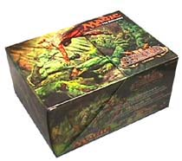
Every year, Wizards of the Coast releases a Magic gift box in time for the holidays. The Beatdown Box was released this week, featuring a number of alternative artwork cards and cool rares. Of special note to collectors are two alternate artwork foil cards - Sengir Vampire and Erhnam Djinn. They look great and should become instant collectibles.
Some of the other rares in the Beatdown set, which is centered around large creatures, include Ball Lightning, Shivan Dragon, Leviathan and Force of Nature.
All cards are white-bordered (except the foils) and feature a spear-like unique expansion symbol.

BEST OF THE NET

The best article on the Net this week isn't about strategy. Instead, Mike Turian takes a very close look at the quality and quantity of strategy content on the Internet, and why readers should not rely entirely on what pros tell them. You can find this article on Mindripper.

PLAY OF THE WEEK
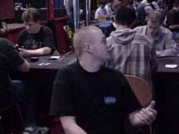
1999 European Champion Nicolai Herzog was playing a Blue Skies monoblue beatdown deck in the Nordic Championship this weekend. His opponent was using an Ankh-Tide strategy - a deck that uses a combination of Ankh of Mishra, Parallax Tide and a number of bounce spells to attack your lands.
Nicolai was in poor position. Down to about six life, he was left with no lands on the table at all through a combination of his opponent's bounce spells and casting his own Dazes and Thwarts. There was no way for him to come back and win that game... or was there?
Nicolai simply stopped playing lands, choosing to do nothing but discard for the rest of the game. His opponent was not prepared for this eventuality and had no other way at all to deal damage to him. Eventually his opponent was forced to concede - or get decked.

